1. Sales Analysis Dashboard: Create a  
   dashboard that shows sales trends over time, by region, and by product category.  
   Use different visualizations to highlight key metrics, such as sales growth  
   rates, top-selling products, and regional sales comparisons.

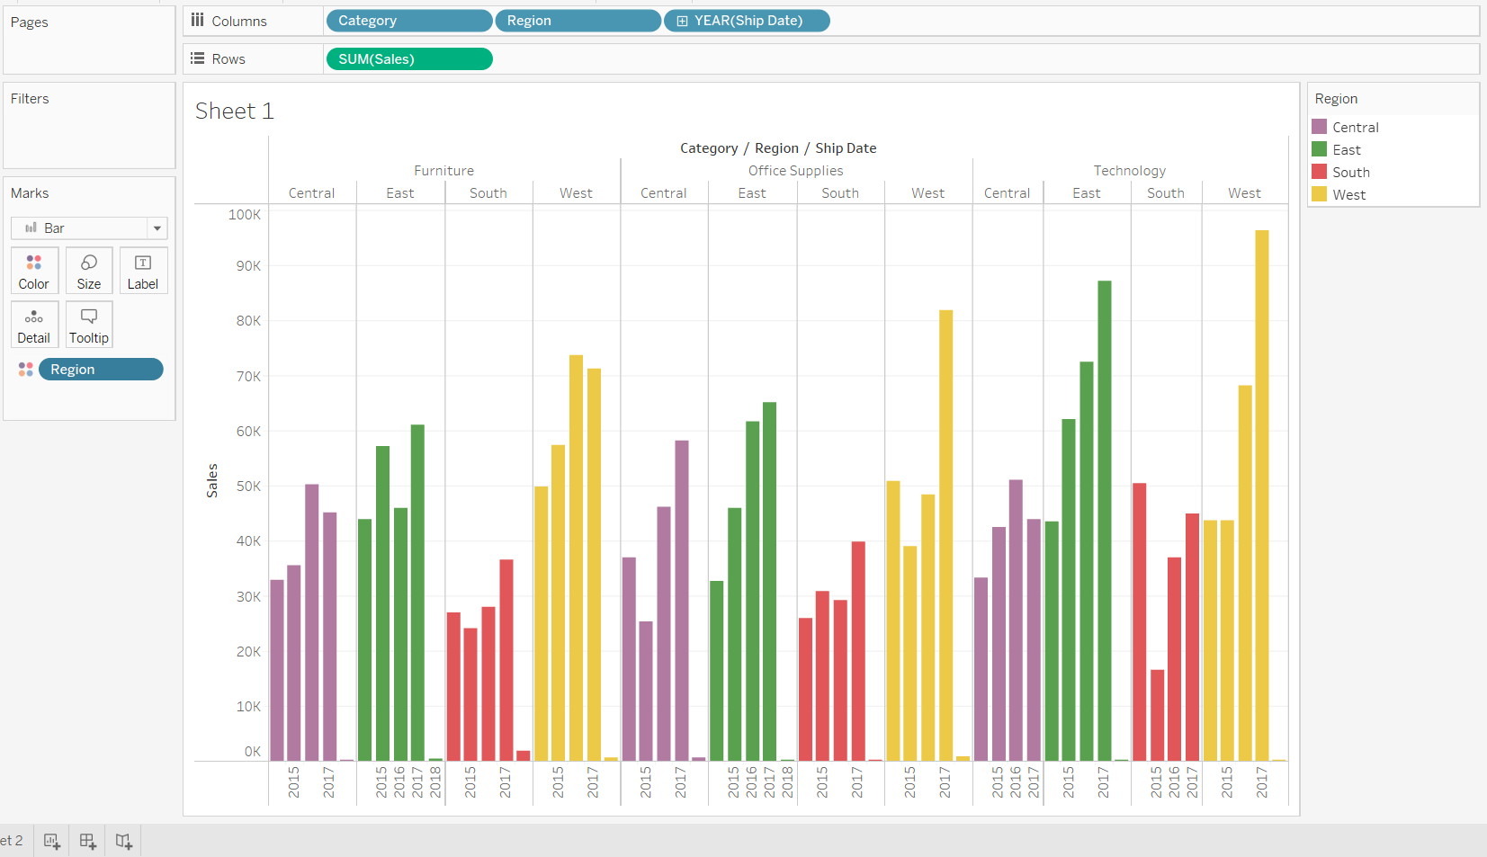

1. Customer Segmentation Analysis: Analyze  
   customer data to identify key segments and create visualizations that show  
   their characteristics, behaviours, and purchasing patterns. Use clustering  
   techniques to group customers into segments, and then create visualizations  
   that show how they differ in terms of demographics, purchasing frequency, and  
   other factors.

